Figures & Tables: A commercial seaweed extract strongly structured microbial communities associated with tomato and pepper roots and significantly increased crop yield

February 05, 2019

**Sébastien Renaut1,2 ,Jacynthe Masse1,2 , Jeffrey P. Norrie3 , Bachar Blal3 Mohamed Hijri1,2**

*1Département de Sciences Biologiques, Institut de Recherche en Biologie Végétale, Université de Montréal, 4101* *Sherbrooke Est, Montreal, H1X 2B2, Quebec, Canada.*  *2Quebec Centre for Biodiversity Science, Montreal, Quebec,*  *Canada*

*3Acadian Seaplant Ltd, 30 Brown Avenue, Darthmouth, Nova Scotia, Canada, B3B 1X8*

**Table 1: summary of PERMANOVAs**

|  |  |  |  |
| --- | --- | --- | --- |
|  | treatment | planting | treatment:planting |
| fungi-soil (tomato) | 0.05*** | 0.24*** | 0.02* |
| fungi-root (tomato) | 0.29*** | NA | NA |
| bacteria-soil (tomato) | 0.06*** | 0.17*** | 0.04** |
| bacteria-root (tomato) | 0.3*** | NA | NA |
| fungi-soil (pepper) | 0.03** | 0.2*** | 0.02* |
| fungi-root (pepper) | 0.1*** | NA | NA |
| bacteria-soil (pepper) | 0.06*** | 0.12*** | 0.02* |
| bacteria-root (pepper) | 0.09*** | NA | NA |

$r^{2}$ (percentage of variance explained by the term in the model); *\*p-value<0.05, **<0.005, ***<0.0005*

Figure 1  
**Figure 1: Measures of plant productivity. *a* and *b* subscripts above boxplots denote significant differences (*p*-value < 0.005) according to the treatment (tomato: hen manure + ANE, pepper: ANE). Fold changes between the mean of the control and treated plants were also noted for significant differences (for pepper and tomato separately).**  
   
   
   
Figure 2  
**Figure 2: Barplots of the relative abundance of fungal ASV for fungi**  
   

Figure 3  
**Figure 3: Barplots of the relative abundance of bacterial ASV for bacteria**  
   

Figure 4  
**Figure 4: Boxplot of $a$-diversity according to the treatment planting effect for fungal-root, fungal-soil, bacteria-soil and bacteria-root for tomato and pepper. *a* and *b* subscripts above boxplots denote significant differences (*p*-value < 0.05).**  
 

Figure 5  
**Figure 5: Redundancy analyses (RDA) for fungal ASV. Labeled samples were colored in gray (unfertilized) or dark yellow (fertilized). Red *+* signs represent individual ASV, while blue *+* signs are the ten ASV most closely associated with the three productivity measures of root fresh weight, shoots fresh weight and fruit number. Blue arrows are the four productivity measures used as constraints in the ordinations.**  

Figure 6  
**Figure 6: Redundancy analyses (RDA) for bacterial ASV. Labeled samples were colored in gray (unfertilized) or dark yellow (fertilized). Red *+* signs represent individual ASV, while blue *+* signs represent the ten ASV most closely associated with the three productivity measures of root fresh weight, shoots fresh weight and fruit number. Blue arrows are the four productivity measures used as constraints in the ordinations.**    
 

**Table S1: Soil characteristics (in ppm unless specified otherwise)**

|  |  |
| --- | --- |
| Soil Characteristics | Average value |
| pH | 6.01 |
| Conductivity (mmhos/cm) | 0.68 |
| Nitrate (N) | 62.40 |
| Ammonium | 0.09 |
| Phosphorus | 0.41 |
| Potassium | 29.30 |
| Calcium | 64.40 |
| Magnesium | 13.80 |
| Chloride | 28.50 |
| Sulfate | 19.30 |
| Sodium | 17.80 |
| Zinc | 0.12 |
| Manganese | 0.06 |
| Cooper | 0.81 |
| Iron | 0.90 |
| Aluminium | 1.66 |

 

**Table S2: Randomized split block design for the tomato and pepper experiments**  
 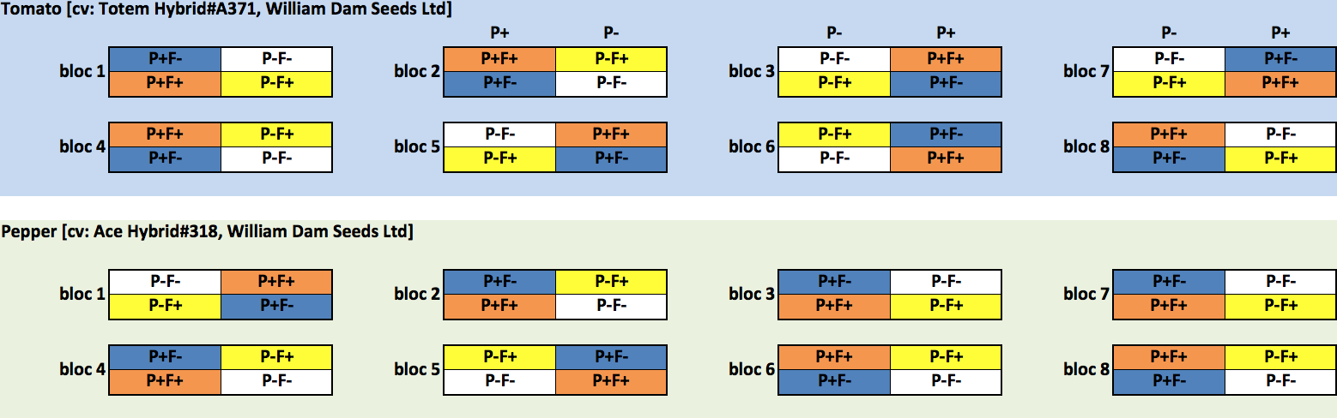

   
 

**Table S3: Stella Maris® characteristics**

|  |  |
| --- | --- |
| Stella Maris® characteristics | Average value |
| Appearance | Viscous Brownish-Black Liquid |
| Odor | Marine Odor |
| Solubility in water (%) | 100 |
| pH | 7.4 - 8.2 |
| Carbohydrates | Alginic acid, Mannitol, Fucoidans |
| Organic matter content (%) | 13.0 - 16.0 |
| Total Nitrogen (N) (%) | 0.1 - 0.6 |
| Available phosphate (P2O5) (%) | < 0.2 |
| Soluble potash (K2O) (%) | 5.0 - 7.0 |
| Sulphur (S) (%) | 0.3 - 0.6 |
| Magnesium (Mg) (%) | 0.05 - 0.15 |
| Calcium (Ca) (%) | 0.05 - 0.15 |
| Sodium (Na) (%) | 0.7 - 1.2 |
| Iron (Fe) (ppm) | 30 - 90 |
| Cooper (Cu) (ppm) | < 4 |
| Manganese (Mn) (ppm) | 3 - 11 |
| Boron (B) (ppm) | 20 - 40 |

   
 

**Table S4: Summary of sequencing statistics and bioinformatics identification of ASV**

|  |  |  |  |  |
| --- | --- | --- | --- | --- |
|  | fungi-soil | fungi-root | bacteria-soil | bacteria-root |
| No sequences (sum) | 976,000 | 309,000 | 920,000 | 535,000 |
| No sequences (mean) | 50,847 | 32,208 | 47,907 | 56,365 |
| No seq. filtered (mean) | 32,626 | 12,714 | 29,662 | 37,642 |
| No seq. filt. merged (mean) | 29,300 | 12,094 | 14,060 | 30,706 |
| No seq. filt. merg. no chimeras (mean) | 25,476 | 9,849 | 13,521 | 30,408 |
| No samples | 192 | 96 | 192 | 96 |
| No samples trimmed | 189 | 81 | 192 | 95 |
| No ASV (sum) | 6,112 | 845 | 9,352 | 2,023 |
| No ASV trimmed (sum) | 413 | 106 | 811 | 325 |
| ASV per sample (mean) | 176 | 37 | 269 | 92 |

**Table S5: summary of PERMANOVAs**

|  |  |  |  |  |
| --- | --- | --- | --- | --- |
|  | fungi-soil | fungi-root | bacteria-soil | bacteria-root |
| fertilization | 0.02*** | 0.08*** | 0.04*** | 0.07*** |
| planted | 0.21*** | NA | 0.13*** | NA |
| species | 0.02*** | 0.26*** | 0.02*** | 0.52*** |
| fertilization:planted | 0.01** | NA | 0.02*** | NA |
| fertilization:species | 0.01* | 0.04* | 0.03*** | 0.05*** |
| planted:species | 0.01 | NA | 0.01** | NA |
| fertilization:planted:species | 0.01 | NA | 0.01* | NA |

$r^{2}$ (percentage of variance explained by the term in the model); *\*p-value<0.05, **<0.005, ***<0.0005*

   
  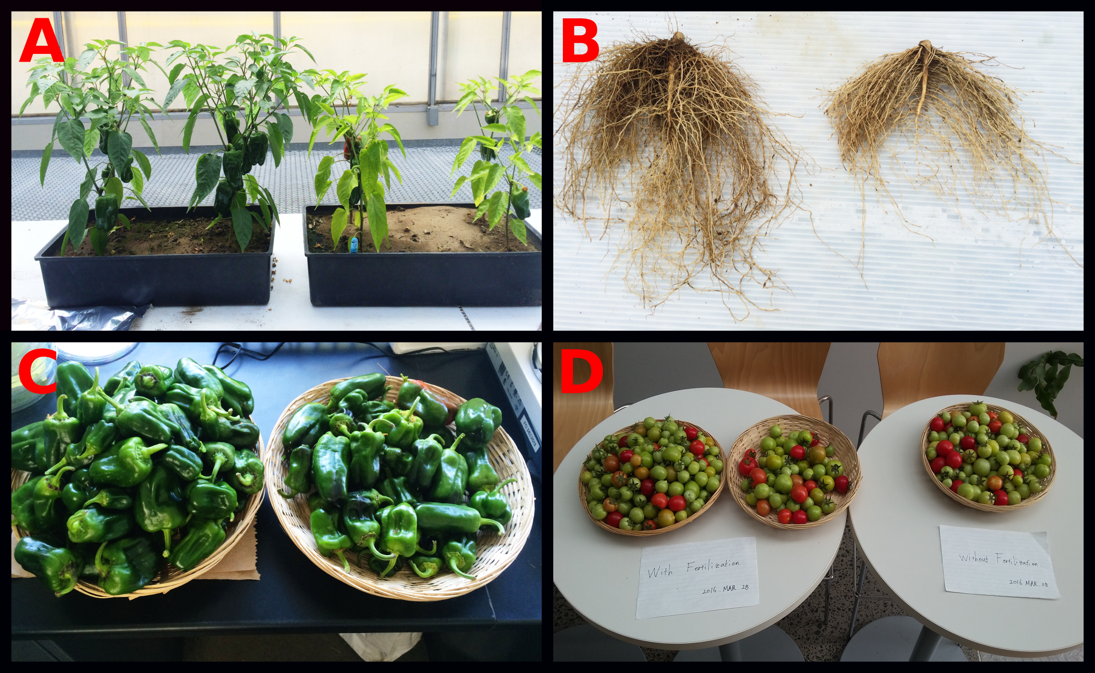  
**Figure S1: Plant productivity. Photos were taken at the end of the experimental treatment. In each photo, treated plants are on the left. A: pepper shoots, B: pepper roots, C: pepper fruits and D: tomato fruits.**

Figure S2  
**Figure S2: Neighbor-Joining trees of candidates ASV (fungi) positively associated with productivity measures. The most accurate taxonomy assigned according to the RDP bayesian classifier (form Phylum to species) was added as tip labels.**    
 

Figure S3  
**Figure S3: Neighbor-Joining trees of candidates ASV (bacteria) positively associated with productivity measures. The most accurate taxonomy assigned according to the RDP bayesian classifier (form Phylum to species) was added as tip labels.**    
 